Hollie’s Journal
English 1302
10am—Spring 2011
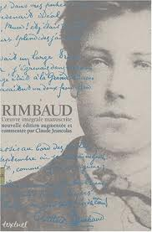
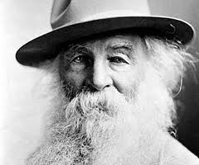
Favorite Reading: Cat on a Hot Tin Roof by Tennessee Williams: I admire his grasp of dialect, the realism of his stories, and the depth of his characters.

Table of Contents [Just an example—make up your own titles]
Inside the Cave……………………….1
Williams & Miller……………………2
Biff & Brick…………………………3
Rimbaud’s Genius…………………….4
My Visionary…………………………5
Transcendental Peace…………………6
Cummings’ Inspiration………………..7
My Birches Moment…………………...8
My Father……………………………9
Final Thoughts……………………….10

